This is how a text font of 12 size looks like. - 3 Pages

Executive Summary - (comes at first and written at last)

- Problem statement -
Microsoft Copilot is evolving from an AI assistant that responds to prompts into an agentic system that can proactively execute multi-step tasks on behalf of users. The challenge is to drive adoption of these capabilities while ensuring that adoption translates into sustained user value—not just increased usage or short-term experimentation.

- Goals and What are my non-goals -
  - Goals
    - Increase the number of tasks completed by Copilot across all Microsoft applications
    - Task success rate for all tasks asked to the Copilot
  - Non-goals
    - Introduce a new standalone application or destination for Copilot's agentic capabilities.
    - Require users to leave their current workflow or application to complete an agentic task.
    - Not focusing on video creation at this point
- Success metric
  - North Star - Increase Copilot commercial adoption and usage month over month.
  - L1 - Number of adoptions ,# tasks per users
  - Counter - Task drop rate, D30 inactivation rate, User intervention rate — % of agentic tasks requiring substantial user intervention before completion.
- User Journey - Empathy Map
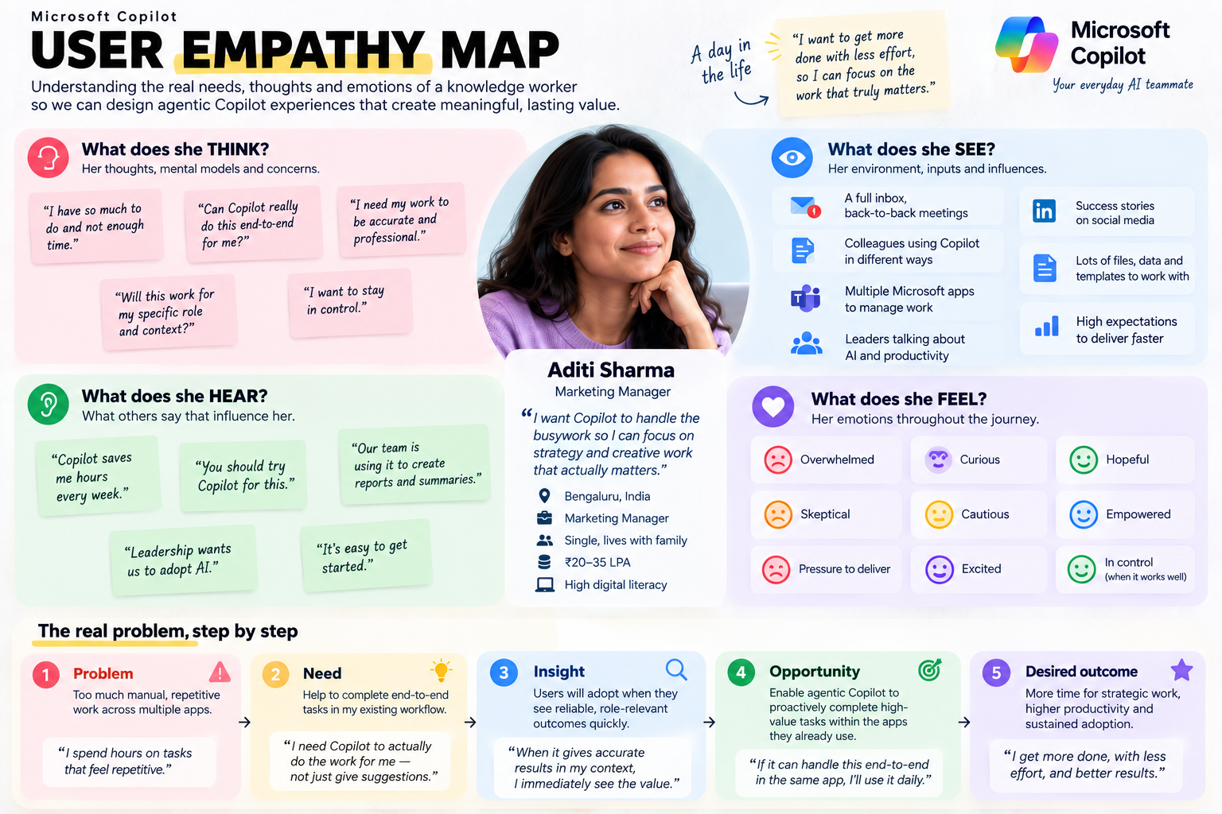
- What is the competitor offering
  - Say What, Not How — Users describe the desired outcome, and Copilot autonomously determines and executes the steps required.
  - Connector → Browser → Computer Execution — Copilot uses the best available access path to complete tasks, even when native integrations are unavailable.
  - Long-Running Work with State — Copilot can work on complex tasks over time, maintain context, and return with a completed outcome.
RICE-inspired prioritization

Opportunity | Reach | Impact | Confidence | Effort | Priority
Say what, not how | MED | HIGH | MED | MED | P0
Connector → Browser → Computer execution | HIGH | HIGH | HIGH | MED | P1
Long-running work with state | MED | MED | HIGH | HIGH | P2

- FUNCTIONAL AND ACCEPTANCE CRITERIA / NON-FUCTIONAL REQUIREMENTS
  - Functionals - Users can submit a task through text or voice, and Copilot should autonomously plan and execute the required steps with minimal user intervention.
  - Non-functional requirement -
    - P - performance - Simple tasks should complete within 45 seconds; long-running tasks should provide progress updates and an estimated completion time.
    - Q - Quality - completed tasks should meet the user's requested outcome with minimal corrections or rework.
    - R - Reliability - the user should be able to recover, restore and re-trigger the chats without losing context
    - S - ˘Secure - User data must be encrypted in transit and at rest, with access limited to authorized services and users.
    - T - Transparency - All executions should have a clear recoverable log and chain of thought for the user
    - U - Useability - All actions should complete within 3-4 prompt interactions.
- MOCK-UP - tool link - https://stitch.withgoogle.com/
- PROTOTYPES (TENTATIVE)
- GITHUB PUSH AS A PORTOLIO

